ULINK API Claims Automation Demo

1. Demo Summary

Step 1 - API claim submission initiated
A test claim was submitted via the Claim Submission API to demonstrate the end-to-end API claim processing flow. This represents the system-to-system intake route for the API demo.
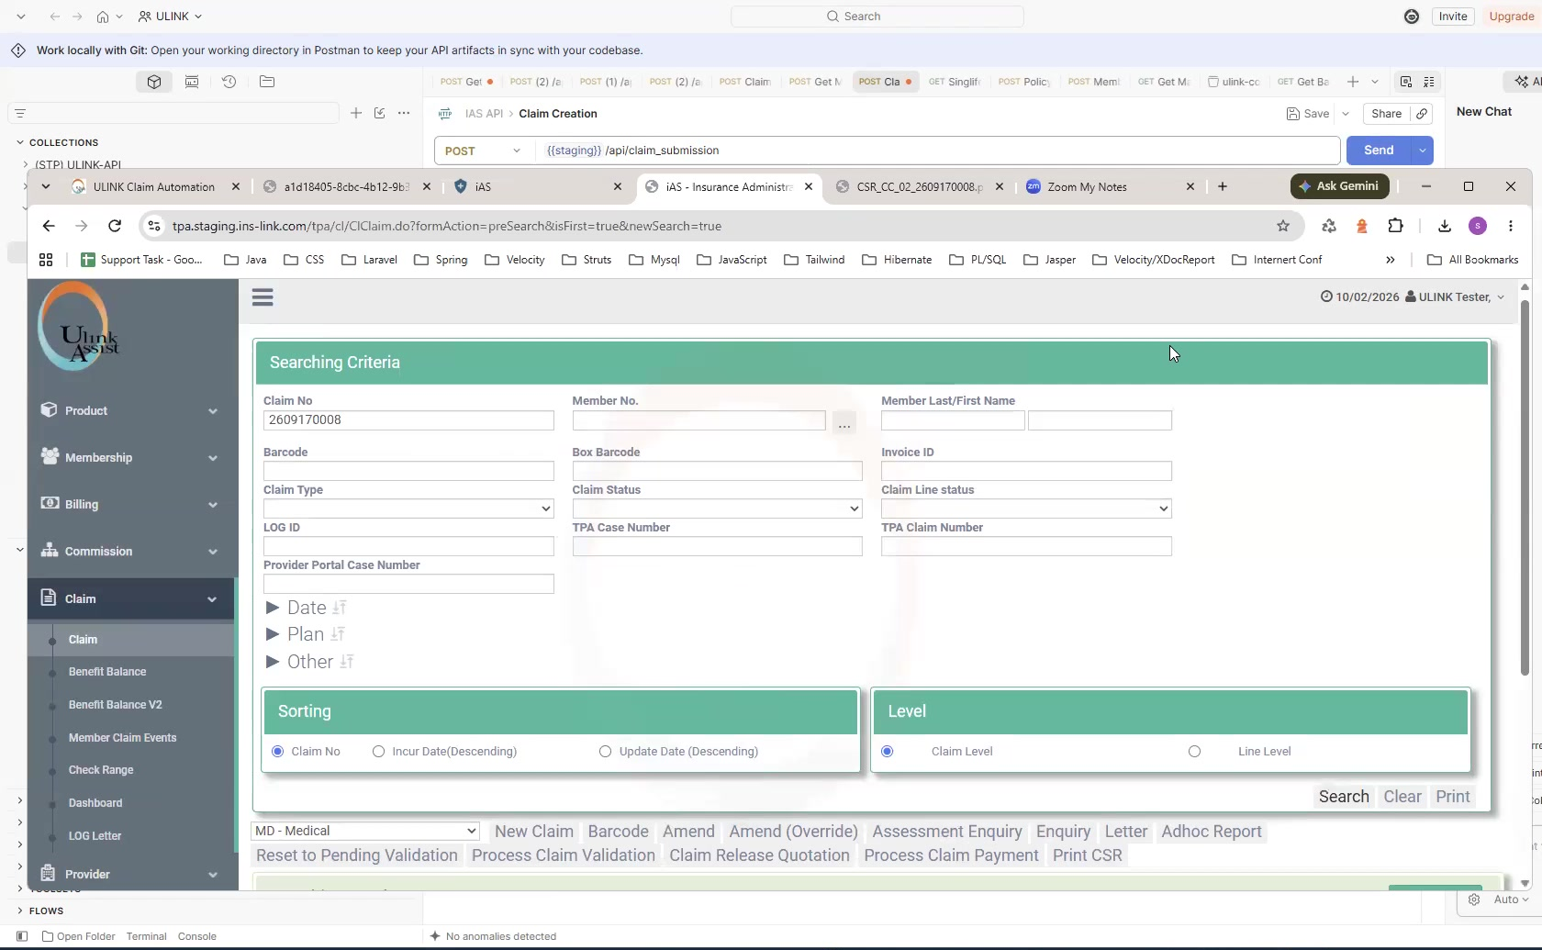
API submission demo: test claim submitted through the Claim Submission API.

Step 2 - Claim created in iAS and document retrieved from the iAS Console
Following the API submission, the claim is created in iAS. The supporting claim image/document then appears in the iAS Console based on the normal 5-10 minute refresh cycle. Using the TPA Case / Claim Number, the AI locates the correct claim document, attaches the Submission # barcode back to the corresponding iAS claim number, and downloads the attachment for OCR review.
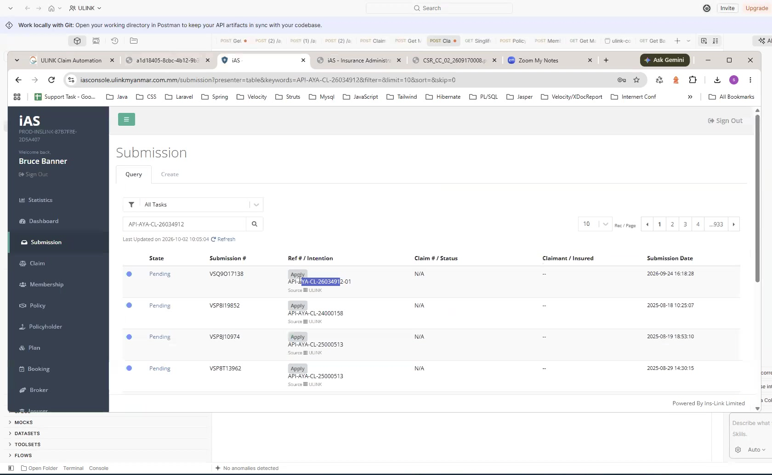
iAS Console: the claim document is matched to the correct iAS claim using the TPA Case / Claim Number and Submission # barcode before the attachment is downloaded for OCR review.

Step 3 - API case entered the ULINK automation pipeline
After the claim attachment is retrieved for OCR review, the API case progresses through the dedicated ULINK API Pipeline. The pipeline shows the automated processing stages, including claim recognition, member verification, document checking, claim preparation, STP assessment and downstream iAS processing.
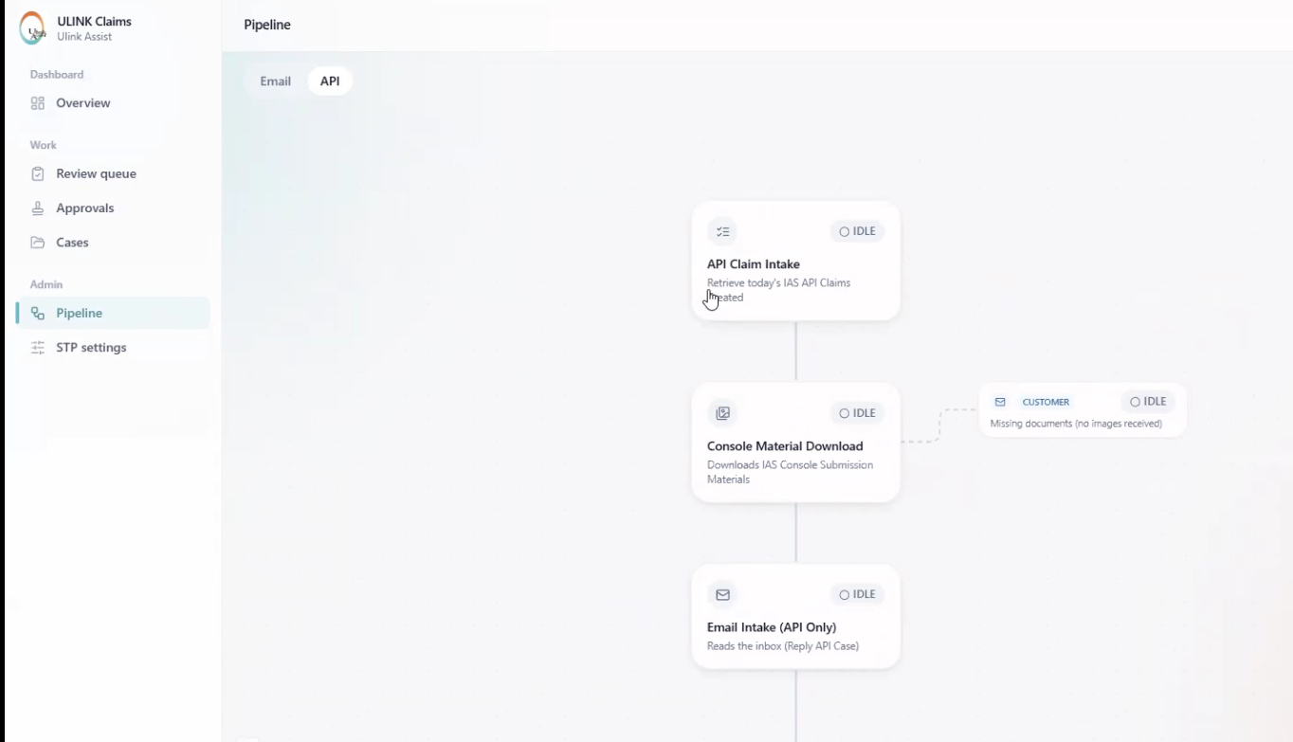

Step 4 - AI validation, member checks and document checks
The case detail view was used to review what the AI had extracted and validated. The system cross-checked member information, claim/documents, diagnosis, benefit mapping and other consistency checks. The case page also explained why the claim followed its current route, rather than showing only a final status.
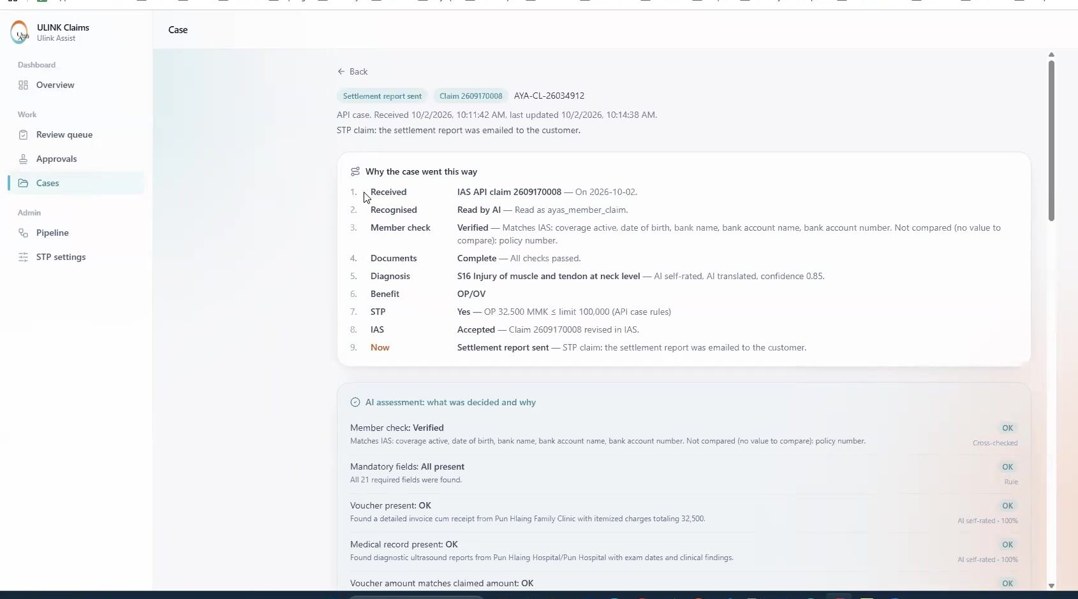

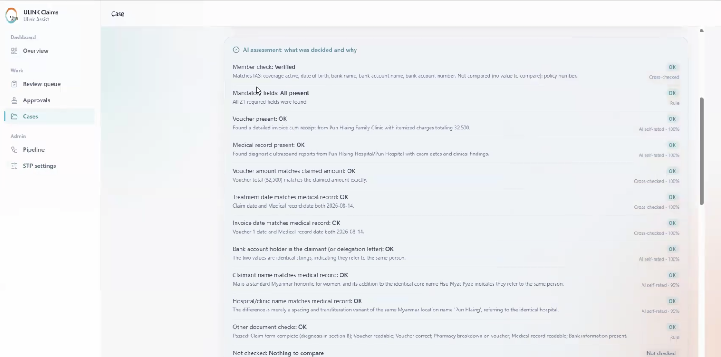
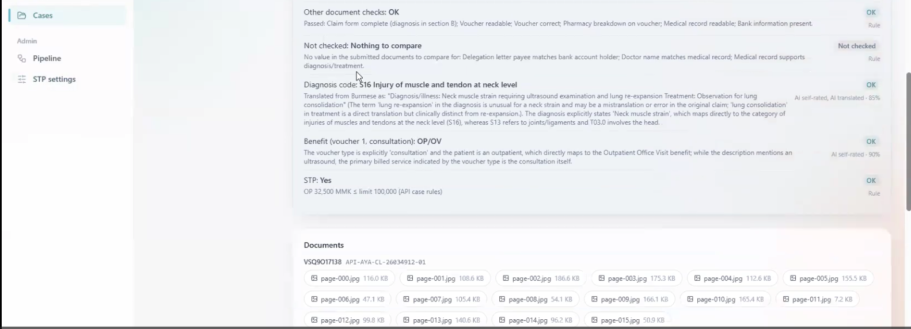

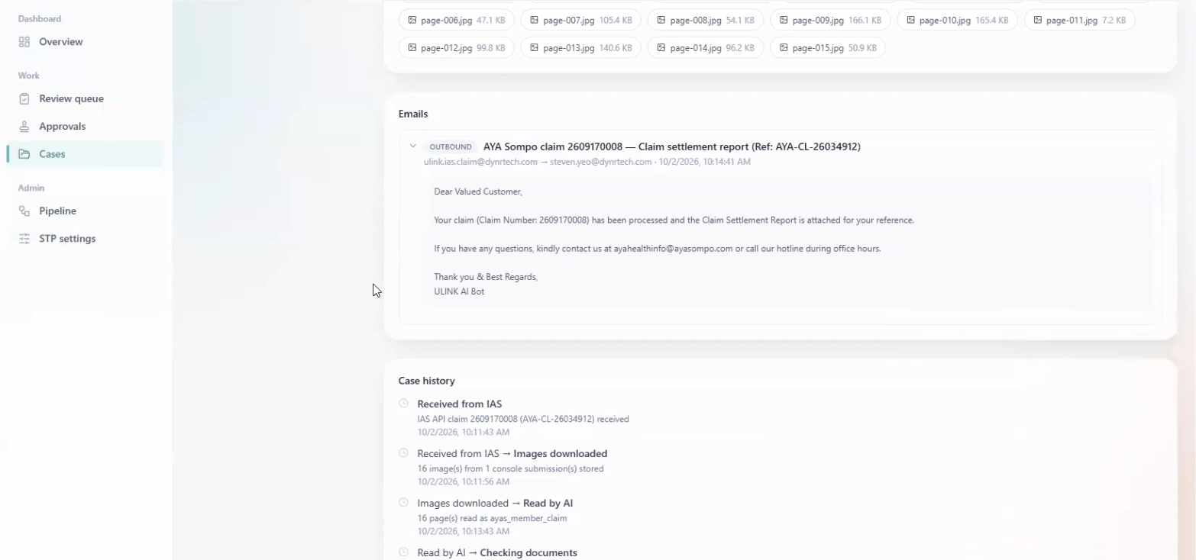
Case explanation / AI assessment view showing the audit trail behind the case outcome.

Step 5 - STP eligibility was evaluated
The demo then showed the STP control logic. STP can be configured separately for Email and API cases using benefit eligibility, maximum claim amount and diagnosis exclusions. The API example demonstrated a claim amount of 32,500 MMK against a 100,000 MMK API STP limit, allowing the case to continue through STP when the other checks passed.
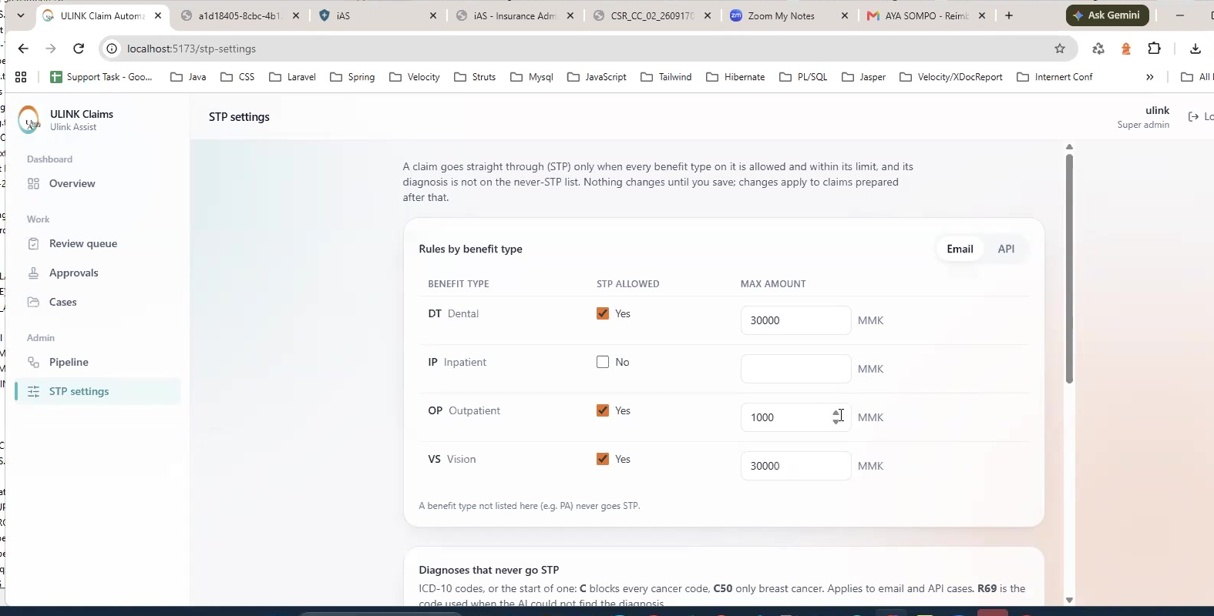
STP settings: configurable benefit limits, diagnosis exclusions and human-check safeguards.

Step 6 - Claim processed in iAS and AI summary recorded
Once the API case passed the automated checks and STP logic, the claim was processed in iAS. The demonstrated case was linked to claim number 2609170008, with 32,500 MMK shown as the processed amount. The user can also view the AI summary remark in iAS for reference.
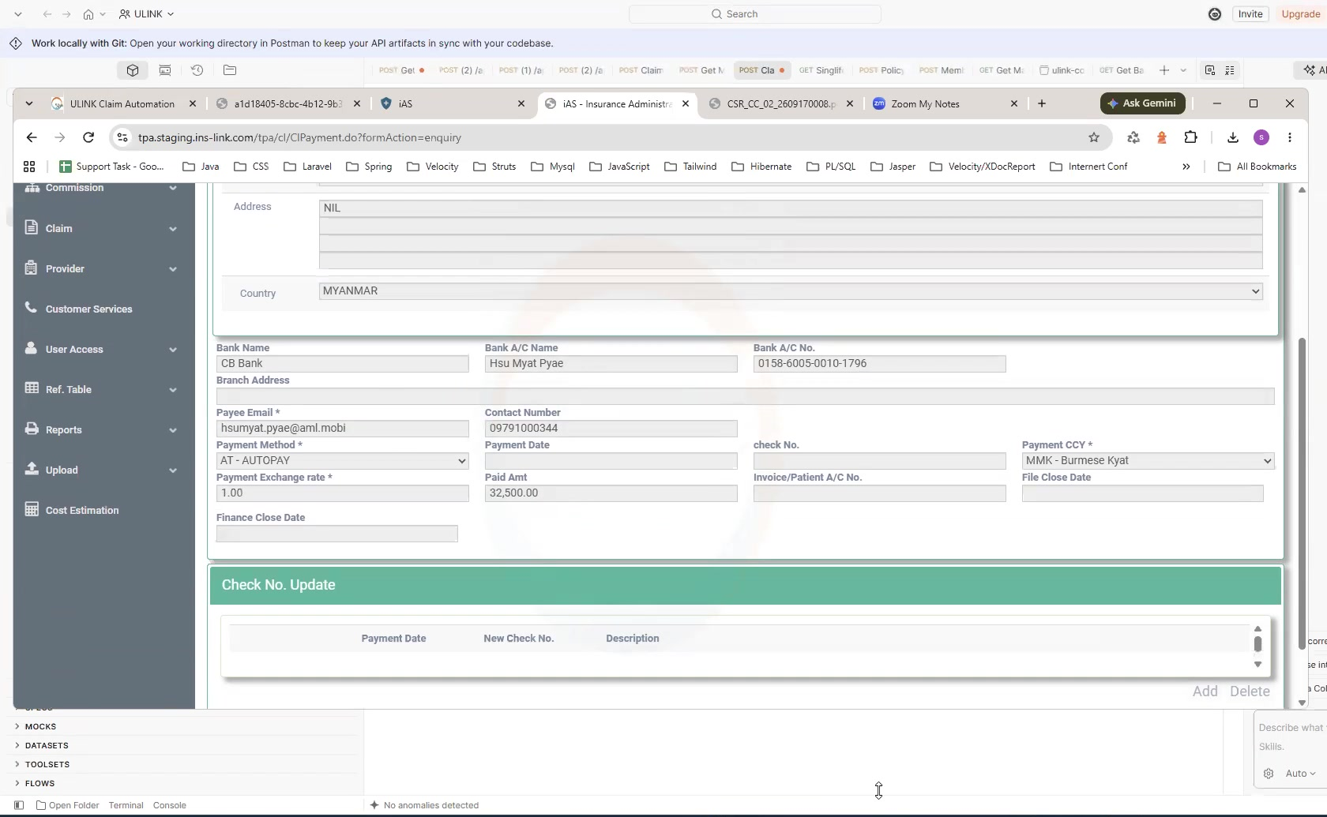

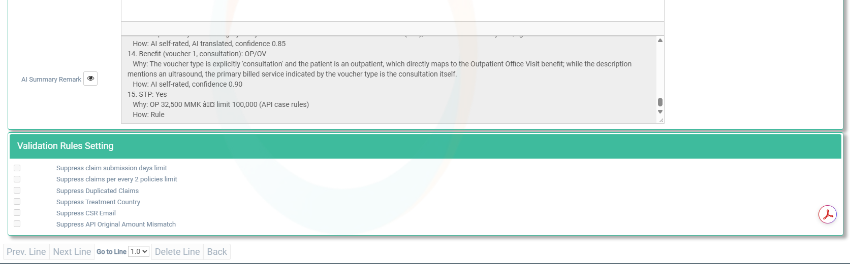
iAS claim/payment details for the demonstrated API case.

Step 7 - Settlement communication was generated
After successful processing, the system generated the customer settlement email and attached the Claim Settlement Report. This demonstrated that the API route can complete the same end-to-end outcome as an email claim when all checks are satisfied.
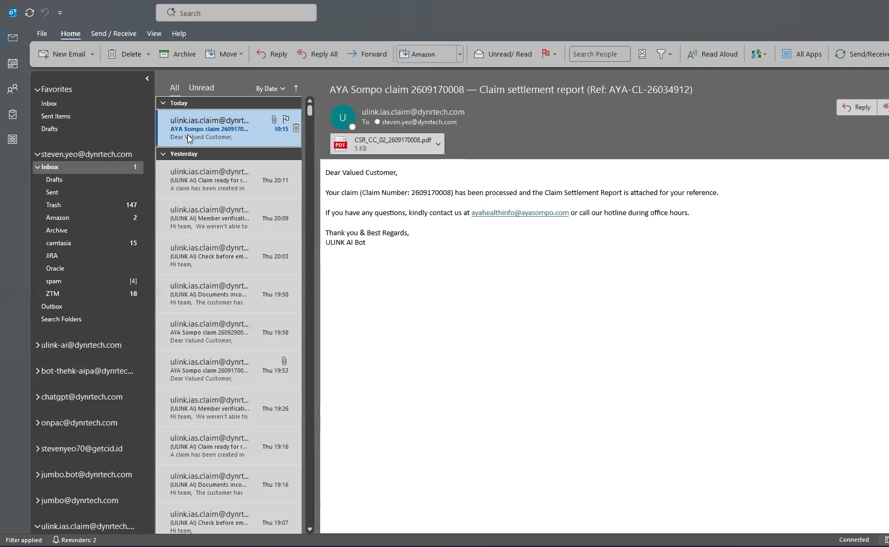
Automated customer settlement email with the Claim Settlement Report attached.

Step 8 - Operational dashboard, exception handling and human-review controls were reviewed
After the successful API example, the discussion moved to the operational dashboard and exception handling for both Email and API cases. The team reviewed the Overview, Review Queue, Approvals, Cases, Pipeline and STP Settings screens, together with the human-review and override workflow used when the AI is uncertain or a case cannot proceed through STP.

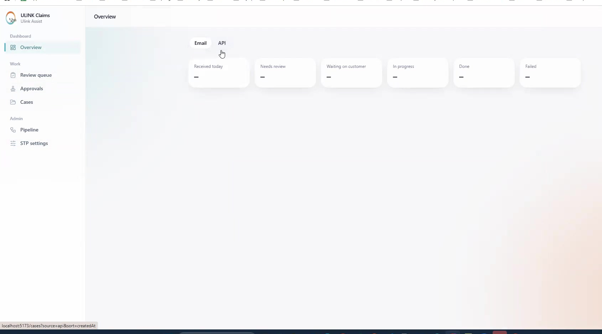
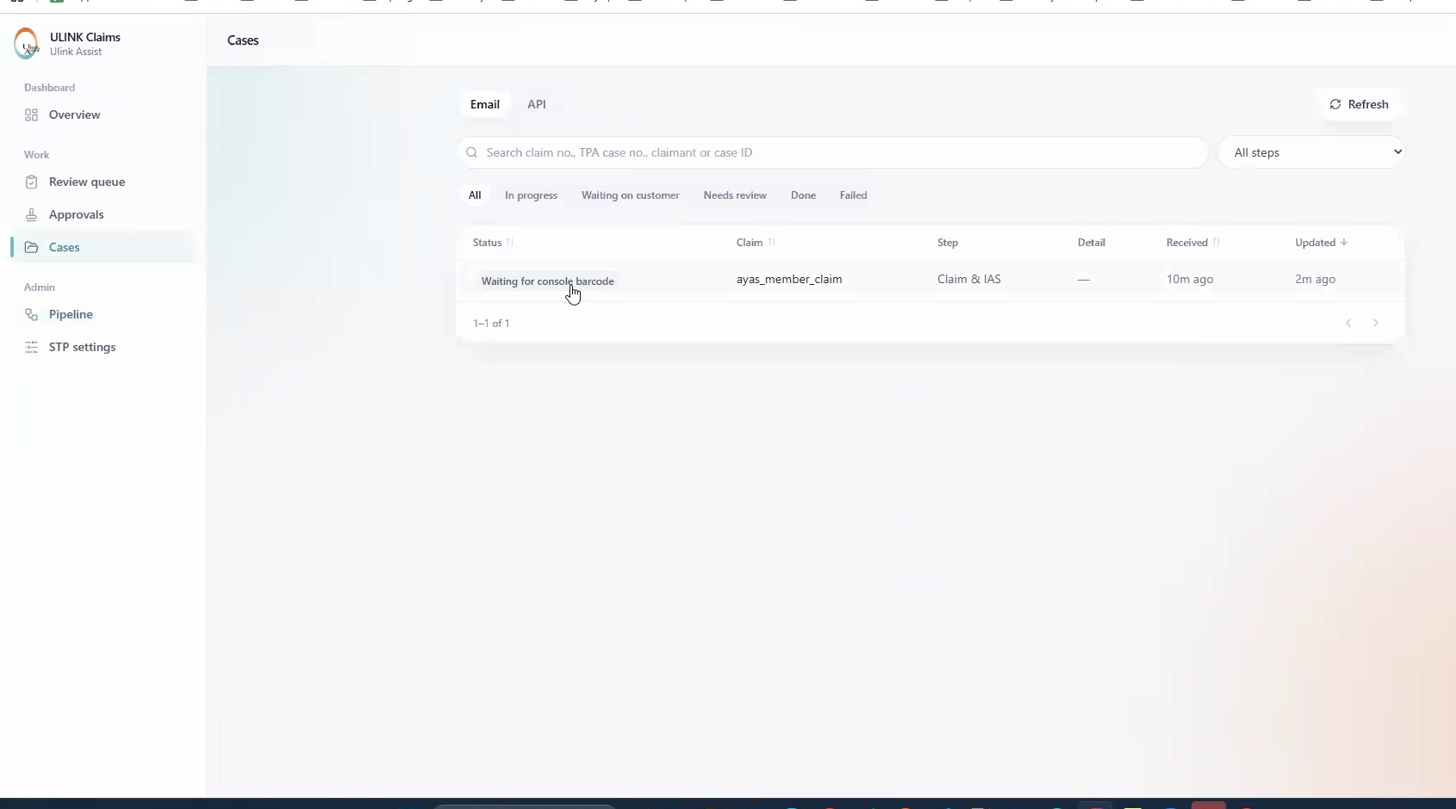

Review Queue - claims that require a user to check or make a decision.
Approvals - claims that passed the automated checks but cannot proceed through STP and require approval.
Cases - the complete case list for search, filtering and monitoring.
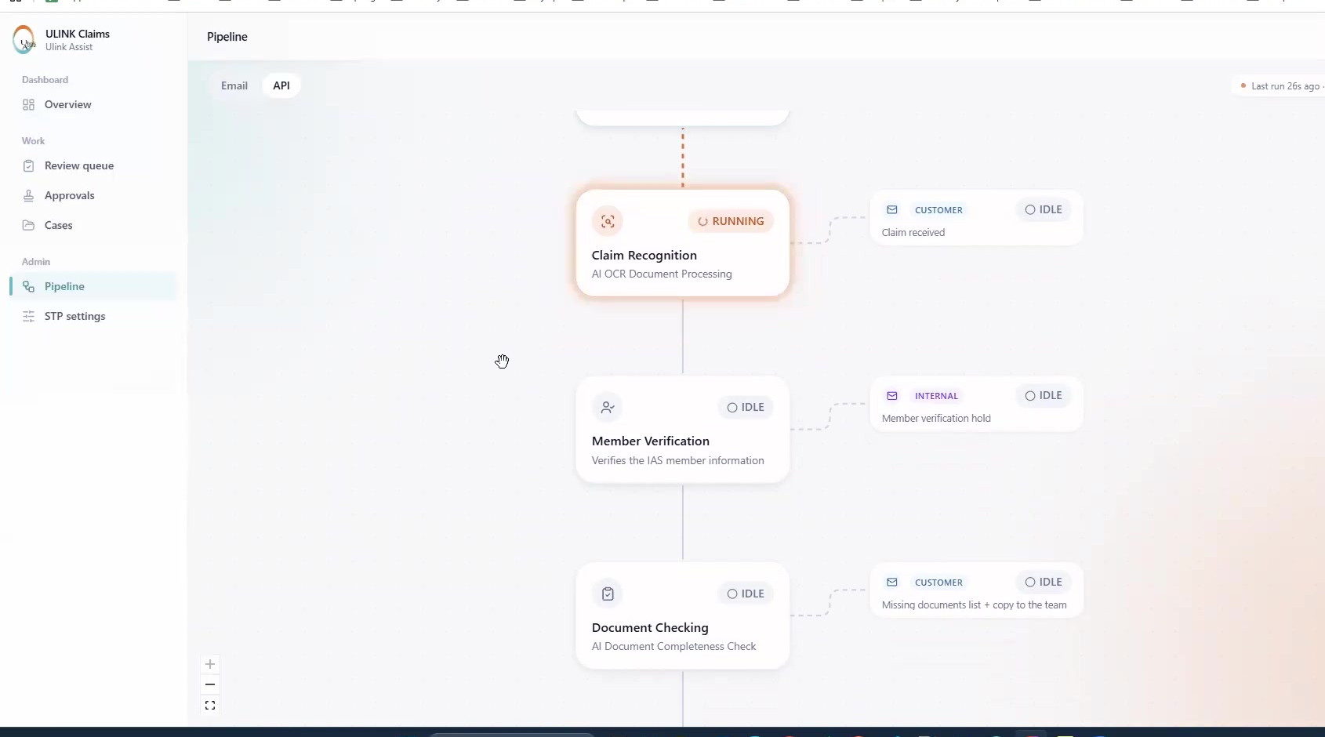
Pipeline - shows the AI assessment workflow and processing status for both Email and API cases.

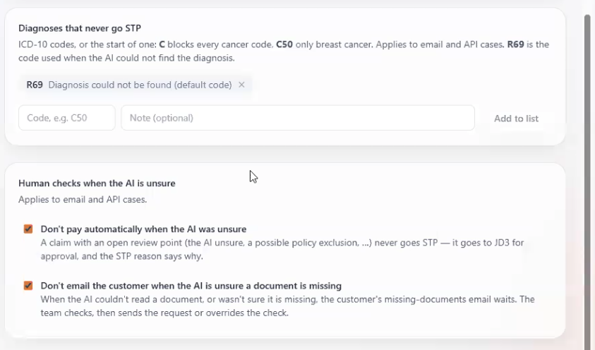
STP Settings - allows users to configure STP conditions for claims.
The settings can control benefit/claim type, claim amount, diagnosis exclusions and situations where the AI is unsure and human review is required.

Cases screen used for operational search, filtering and monitoring.

Human review and AI override
For uncertain document findings, the dashboard is designed to stop uncontrolled automation and route the case to a person. A reviewer can compare the AI finding with the source document, override an incorrect result and retain the reason for the override. One example discussed involved an invoice-date interpretation issue.
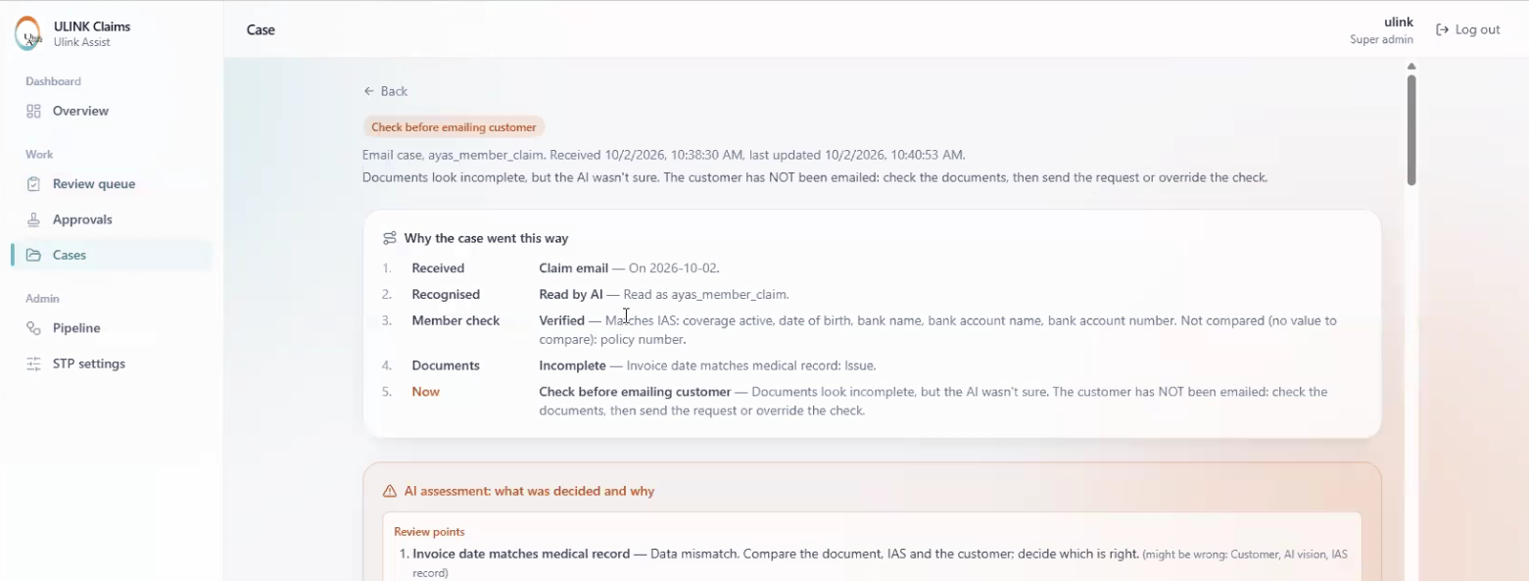

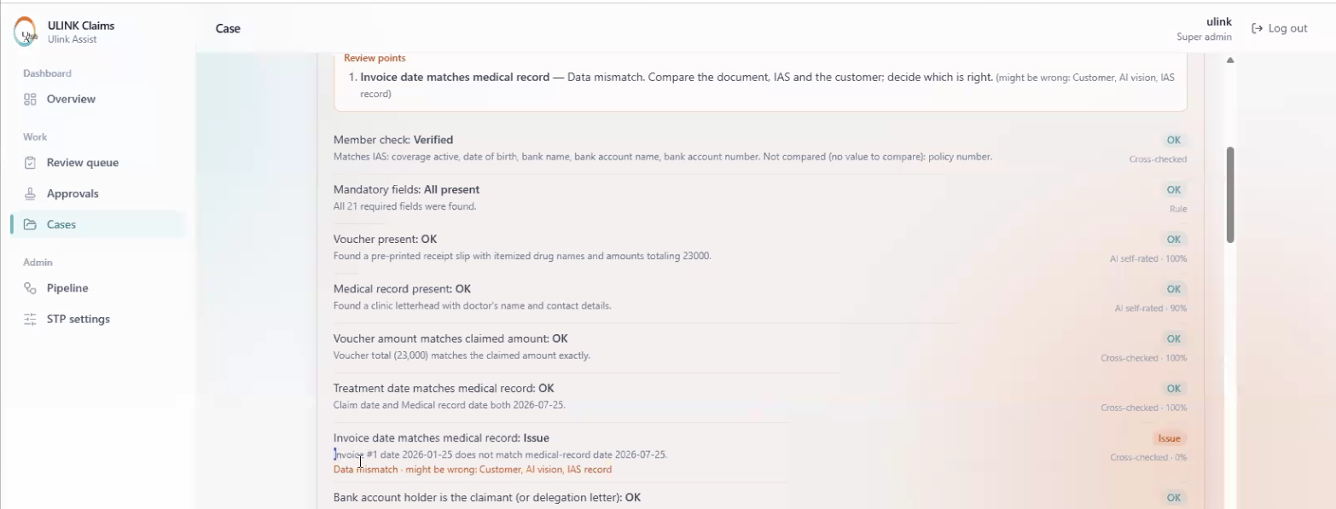
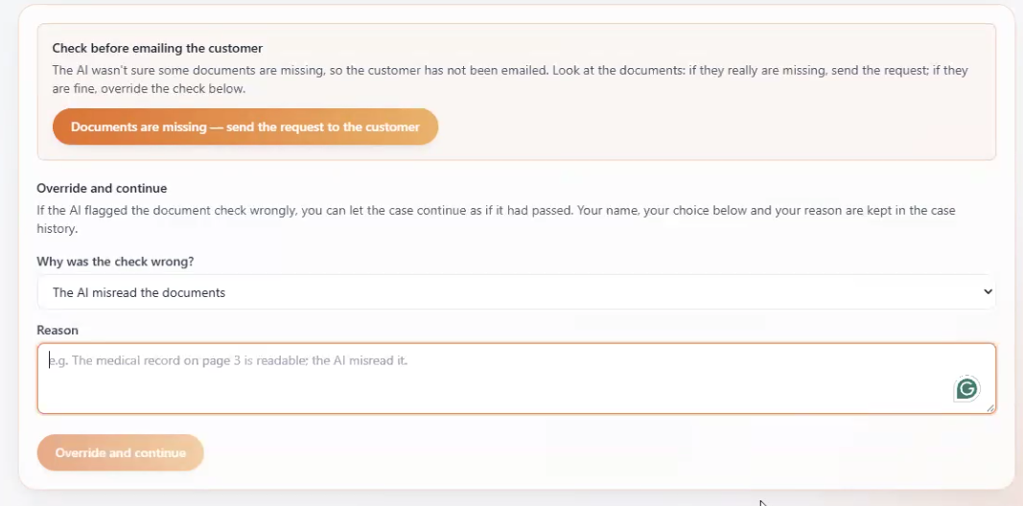
After the reviewer overrides or resolves the issue, the case can continue through the pipeline workflow again.

Exception / human-review screen: reviewer checks the AI finding before the case proceeds.

Operational overview and pipeline monitoring
The later part of the session revisited the operational views. The Overview separates Email and API activity and shows key statuses such as received, needs review, waiting on customer, in progress, done and failed. The Pipeline shows where the automation is currently running, complete or idle, while the Cases screen provides case-level monitoring.
Overview dashboard: Email/API activity and status counts.
Pipeline view: current automation stage and processing status.

Step 9 - Session closed with pending development and sample-case actions
The final discussion returned to the project action list. The remaining work was split between DRT system/deployment items and ULINK sample cases / business inputs required to test and refine the solution.

Closing project notes showing the 02-Oct-2026 enhancement items.

2. Pending Action Items - DRT and ULINK
The pending items below combine the development points discussed in the meeting with the sample cases and business inputs required from ULINK for further testing.

2.1 DRT - Development / System Actions
No. | Owner | Pending action | Status / next step
1 | DRT | Add / improve the iAS remark preview so the reviewer can see the full remark without working from a truncated view. | Pending development
2 | DRT | Capture structured feedback from human review / override decisions so the reason for correcting an AI result is retained and can be used for improvement. | Pending development
3 | DRT | Ensure document-checking uncertainty does not continue through STP automatically; uncertain document findings should be routed to human review. | Pending control change / validation
4 | DRT | Correct and refine the AI summary / reviewer checking list so the information shown to the reviewer is clear and complete. | Pending refinement
5 | DRT | Enhance AI detection for supplements and vitamins and route these items for manual approval even when the claim would otherwise qualify for STP. | Pending development
6 | DRT | Introduce manual rejection fields / workflow: Reject Code, Rejected Amount and Reject Remark. | Pending development
7 | DRT | Develop a more consolidated overall console/dashboard covering both Email and API processing. | Pending design / development
8 | DRT | Complete deployment of Burmese translation support in the claims automation solution. | Pending deployment

2.2 ULINK - Sample Cases / Business Inputs
No. | Owner | Pending action | Status / next step
1 | ULINK | Provide additional sample cases covering IP, DT, VS and Vaccination claims so the different benefit workflows can be tested. | Sample cases to be provided
2 | ULINK | Provide a sample case involving vitamins and/or supplements to test the intended manual-approval handling. | Sample case to be provided
3 | ULINK | Provide a sample case showing how ULINK inputs the manual rejection code, rejected amount and manual rejection remark. | Sample / process example to be provided
4 | ULINK | Provide examples of a Policy Event and a Member Event for system testing and validation. | Examples to be provided
5 | ULINK | Provide the chronic-illness ICD codes that ULINK does not want to proceed through STP, for example HTN and DM. | ICD exclusion list to be provided

3. Recommended Next-Step Sequence
- ULINK provides the requested sample cases and business inputs: IP/DT/VS/Vaccination, vitamins/supplements, manual rejection entry, Policy Event / Member Event examples, and chronic-illness ICD exclusions.
- DRT completes the pending system changes and Burmese translation deployment.
- DRT tests the revised workflow using the ULINK sample cases and confirms the expected Email/API behaviour.
- ULINK performs UAT on successful STP cases, manual-review cases and rejection scenarios.
- ULINK confirms the final production STP rules and chronic-illness diagnosis exclusions before deployment.
- Integration with Freshdesk, arrange Sandbox demo from Freshdesk.

